

**CSE6224 Software Requirement ENG**

**Project Part 1**

**Task 4: Elicitation Execution**

**Title: Campus Event Check-in System (CECS)**

**Prepared By:**

| **Student Name** | **Student ID** | **Email** | **Phone Number** |
| --- | --- | --- | --- |
| ERIC TEOH WEI XIANG | 1221102007 | 1221102007@student.mmu.edu.my | 017-406 3708 |
| PANG TIAN YOU | 1231303394 | 1231303394@student.mmu.edu.my | 011-10943832 |
| SIOW YI LING | 1211107982 | 1211107982@student.mmu.edu.my | 011-10923772 |
| LIM KAI SHEN | 1211110602 | 1211110602@student.mmu.edu.my | 012-2153379 |

## 

# **Table of Contents**

Table of Contents 2

1 Questionnaire Execution 3

1.1 Implementation Details 3

1.2 Sample Questionnaire 4

2 Requirements Categorization Summary 10

3 Execution Evidence and Documentation 13

3.1 Questionnaire Analytics 13

4. Prototyping 21

4.1 Summary Feedback 32

5 System Functionalities 34

5.1 Login 34

5.2 Event Management (Admin) 34

5.3 Event Participation (Student) 35

5.4 Notification and Communication 36

5.5 Cross-Functional Features 36

## 

## 

## 

## 

## 

## 

## **1 Questionnaire Execution**

### **1.1 Implementation Details**

● Platform Used: Google Forms

● Response Period: 4 days (May 15-18, 2025)

● Total Respondents: 44

1. Students: 31

2. Administrators: 13

### **1.2 Sample Questionnaire**

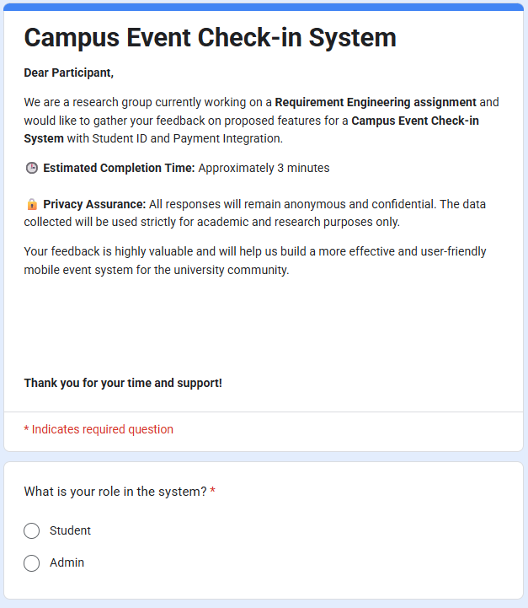

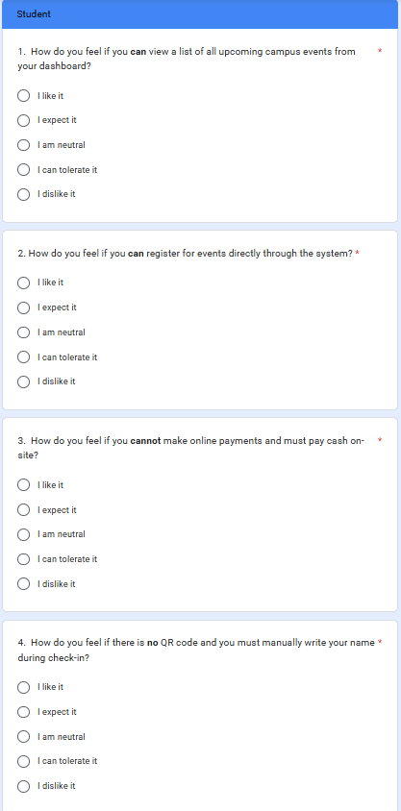

### 

## **2 Execution Evidence and Documentation**

### **2.1 Questionnaire Analytics**

The charts below present the survey findings, with responses categorized according to the Kano model to distinguish must-have features, standard expectations, and delightful bonuses. While a detailed analysis and requirements are outlined in Section 3, this section emphasizes the visual data underpinning those classifications.

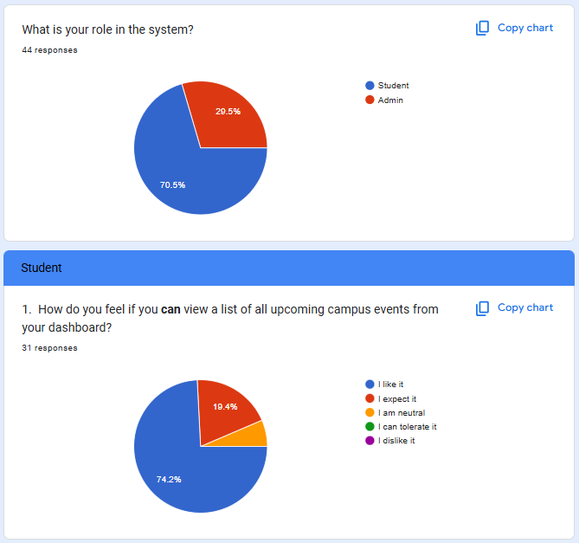

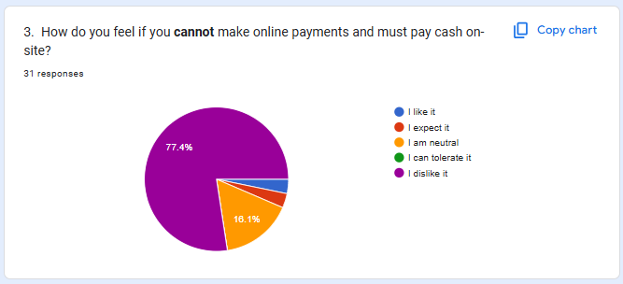

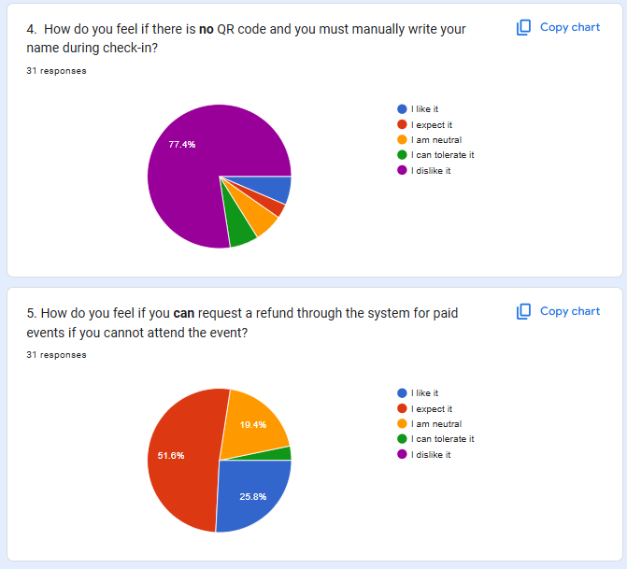

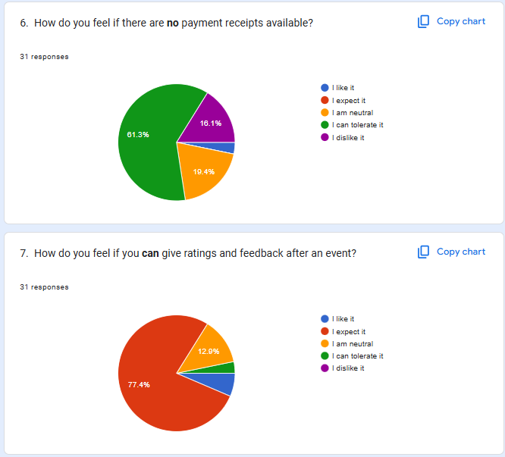

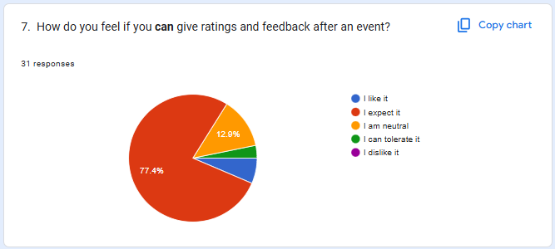

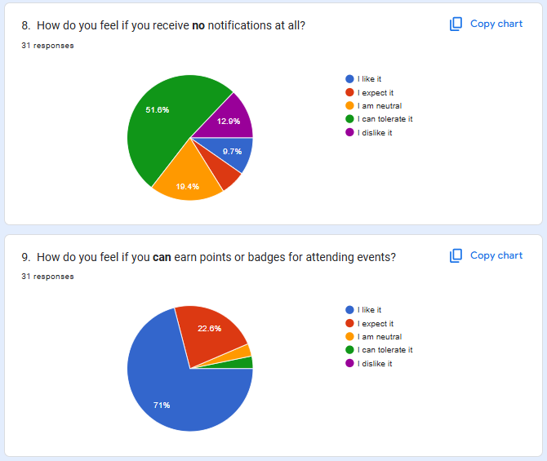

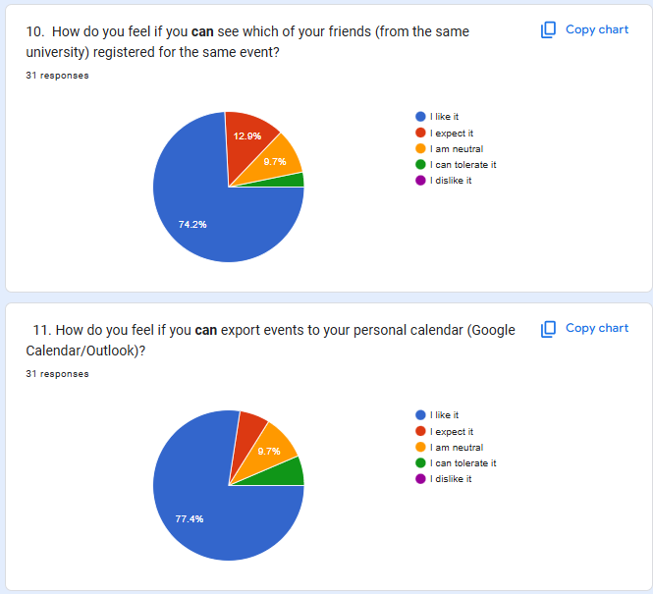

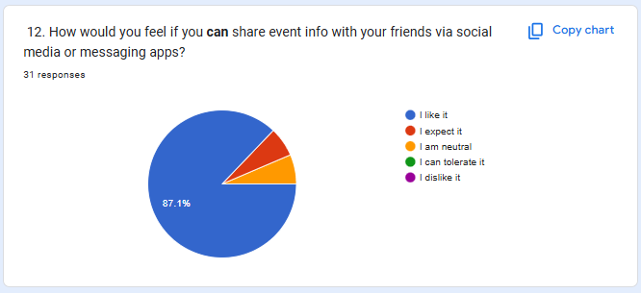

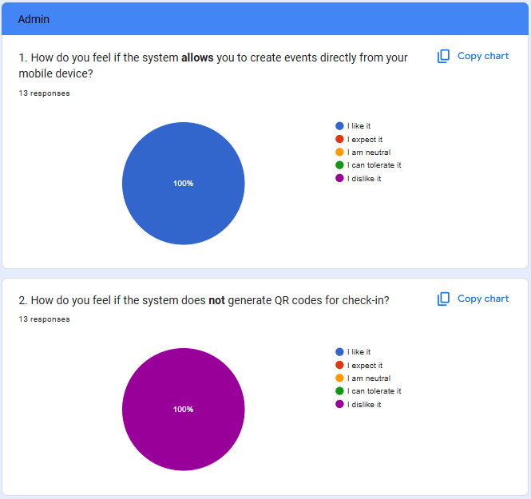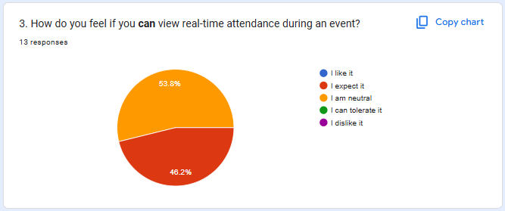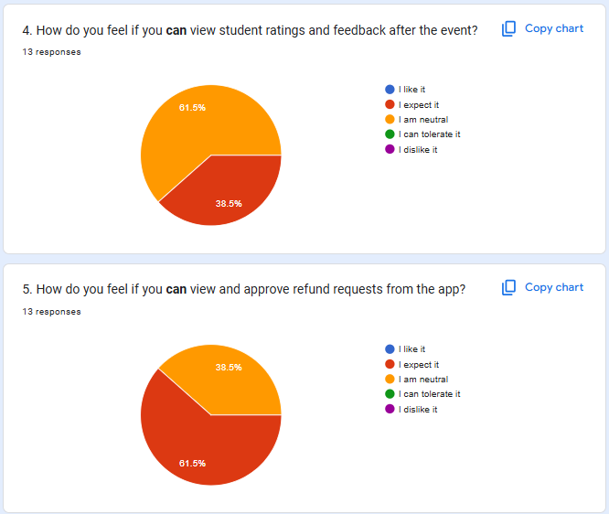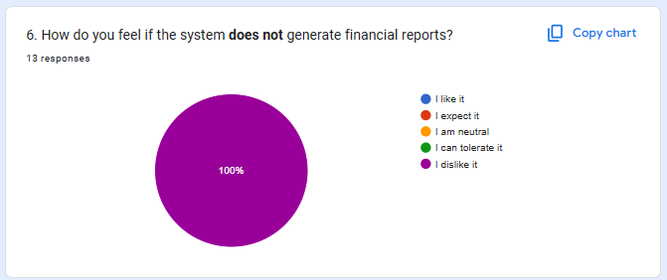

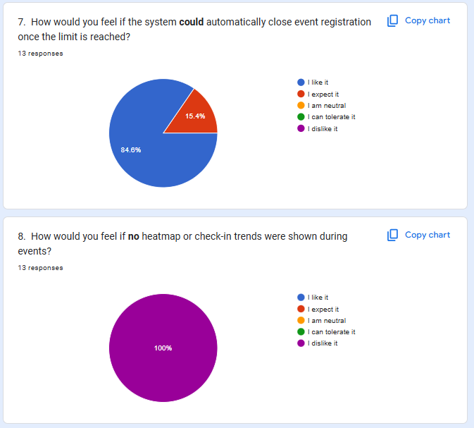

### **2.2 Prototyping**

[Click Here Direct To Our Prototype](https://www.figma.com/proto/zrBmDZk9TZdujGFLCVKrHZ/SOFTWARE-REQUIREMENT-ENGINEERING?node-id=6-4&p=f&t=aafcHEQxmk2yuyWN-1&scaling=scale-down&content-scaling=fixed&page-id=0%3A1&starting-point-node-id=6%3A4&show-proto-sidebar=1)

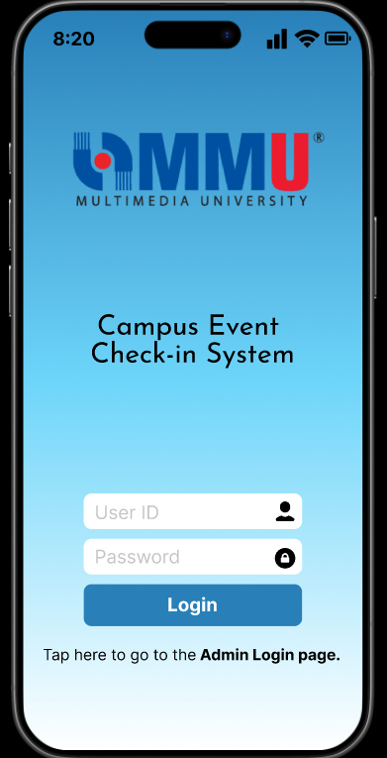

**Figure 2.2.1: Login Page (User)**

This is the sign in page for users of Campus Event Check-in System with Student ID and Payment Integration. In the sign in page, there are User ID input and password input that enable users to enter to the next page. Click the ‘Admin Login page’ can directly move to the admin login page. Users need to click the login button to enter to the next page.

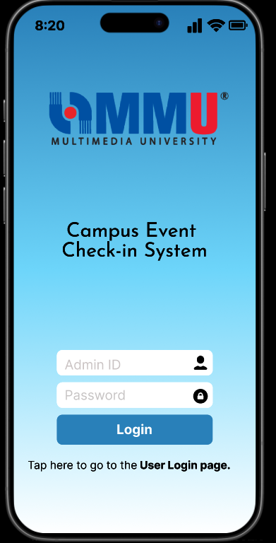

**Figure 2.2.2: Login Page (Admin)**

This is the sign in page for admin of Campus Event Check-in System (CECS). In the sign in page, there are Admin ID input and password input that enable users to enter to the next page. Click the ‘User Login page’ can directly move to the user login page. Admin needs to click the login button to enter to the next page.

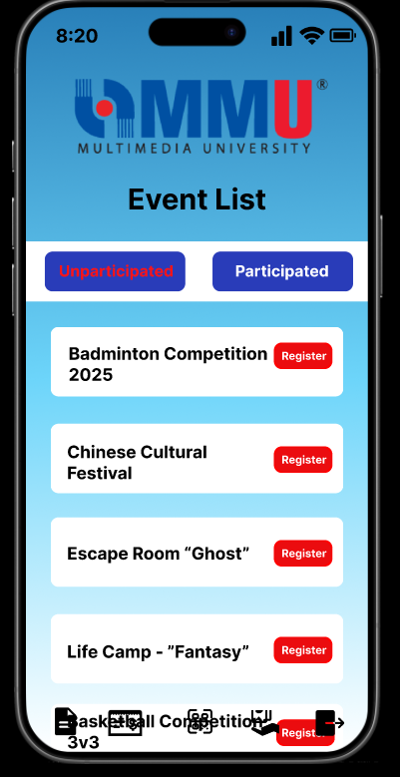

**Figure 2.2.3: Unparticipated Event List Page (User)**

This is the unparticipated event page for users of Campus Event Check-in System (CECS). In this page, users can scroll down to view the event lists and choose events to register. Click the ‘Participated’ can directly view the participated event lists. Users can choose the icon below that represents the function of event lists, payment receipt, scan QR code, refund status and logout.

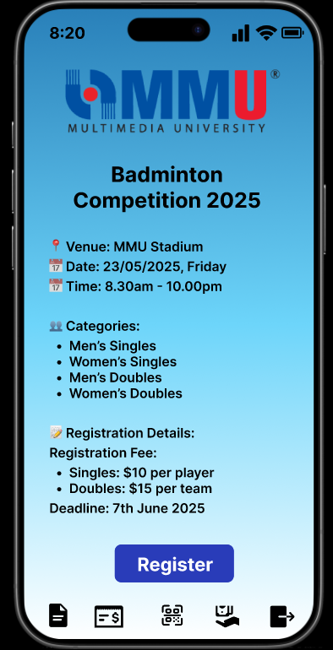

**Figure 2.2.4: Event Details Page (User)**

This is the event details page for users of Campus Event Check-in System (CECS). This page shows the details of the event that users selected to register. Users can click the ‘Register’ button to enter the register event page. Users can choose the icon below that represents the function of event lists, payment receipt, scan QR code, refund status and logout.

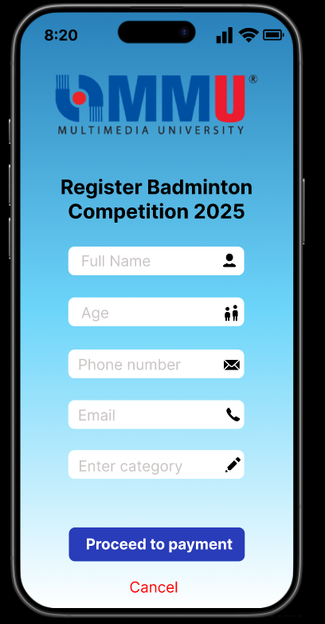

**Figure 2.2.5: Register Event Page (User)**

This is the register event page for users of Campus Event Check-in System (CECS). In this page, users need to insert the full name, age, phone number, email and category of the event. After filling the form, users can click the ‘Proceed to payment’ button to enter the next page. Users can click the ‘Cancel’ button to decline the process.

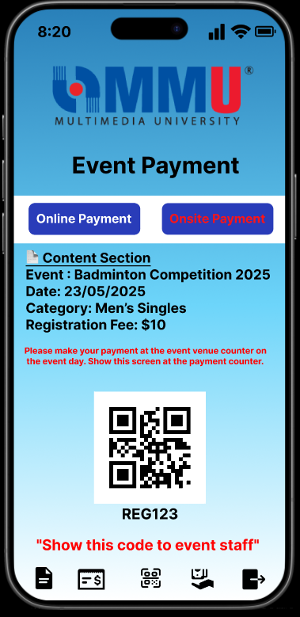

**Figure 2.2.6: Event Onsite Payment Page (User)**

This is the event onsite payment page for users of Campus Event Check-in System (CECS). In this page, users can choose online payment or onsite payment to proceed their payment. Users need to show the QR Code at the counter to do the onsite payment. Users can choose the icon below that represents the function of event lists, payment receipt, scan QR code, refund status and logout.

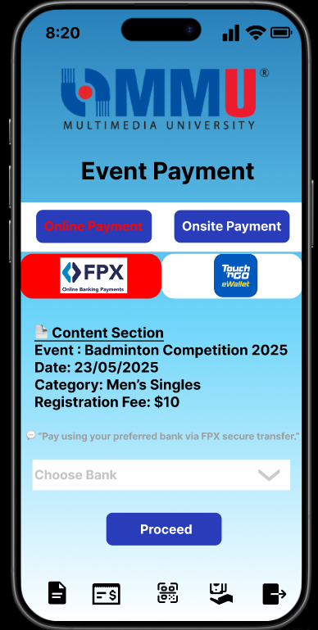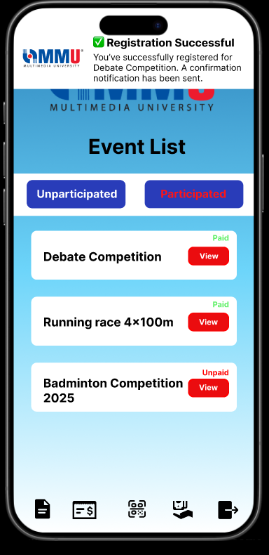

**Figure 2.2.7: Event Online Payment Page (User)**

This is the event online payment page for users of Campus Event Check-in System (CECS). In this page, users can choose online payment or onsite payment to proceed their payment. Users need to choose the method of payment (FPX or Touch N Go) to do the online payment. If users choose FPX, users have to choose the bank. Click the ‘Proceed’ button to finish the payment and it will show the registration successful after done the payment. Users can choose the icon below that represents the function of event lists, payment receipt, scan QR code, refund status and logout.

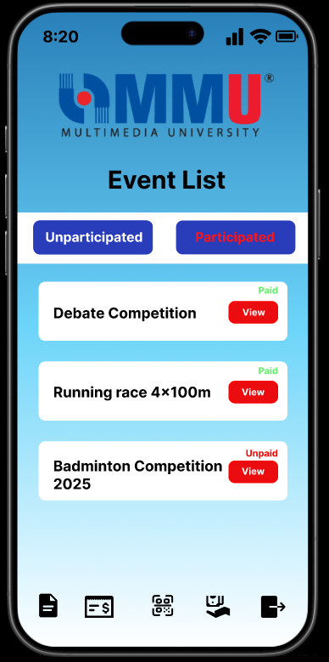

**Figure 2.2.8: Participated Event List Page (User)**

This is the participated event page for users of Campus Event Check-in System (CECS). In this page, it shows the event that has the status ‘Paid’ or ‘Unpaid’. Users can choose the event to view more information. Click the ‘Unparticipated’ can directly view the participated event lists. Users can choose the icon below that represents the function of event lists, payment receipt, scan QR code, refund status and logout.

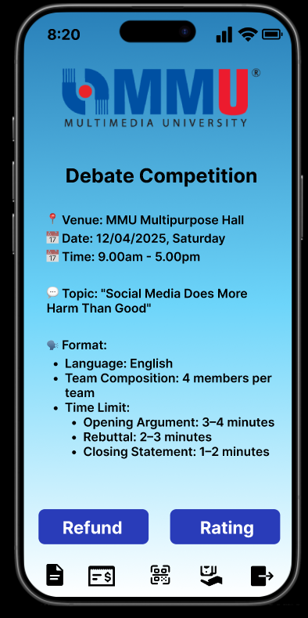

**Figure 2.2.9: Participated Event Description Page (User)**

This is the participated event description page for users of Campus Event Check-in System (CECS). In this page, it shows the event information and the buttons ‘Refund’ and ‘Rating’. If users want to request a refund then click the ‘Refund’ button; If users want to rate the event then click the ‘Rating’ button. Users can choose the icon below that represents the function of event lists, payment receipt, scan QR code, refund status and logout.

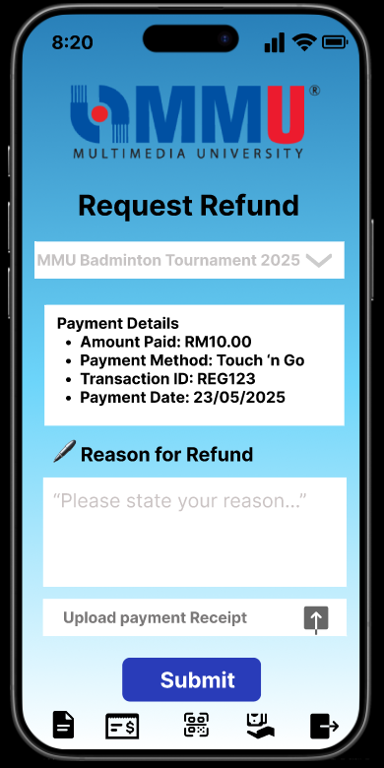

**Figure 2.2.10: Request Refund Page (User)**

This is the request refund page for users of Campus Event Check-in System (CECS). In this page, it shows the event title, payment details, the reason for refund input and requires users to upload their payment receipt. Users need to insert the reasons for refund and upload the payment receipt. Click ‘Submit’ to enter the next page. Users can choose the icon below that represents the function of event lists, payment receipt, scan QR code, refund status and logout.

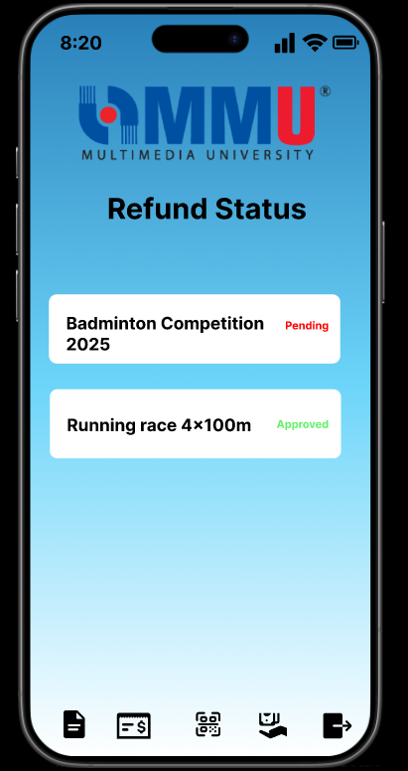

**Figure 2.2.11: Refund Status Page (User)**

This is the refund status page for users of Campus Event Check-in System (CECS). In this page, it shows the event that the status is ‘Pending’ or ‘Approved’. Users can choose the icon below that represents the function of event lists, payment receipt, scan QR code, refund status and logout.

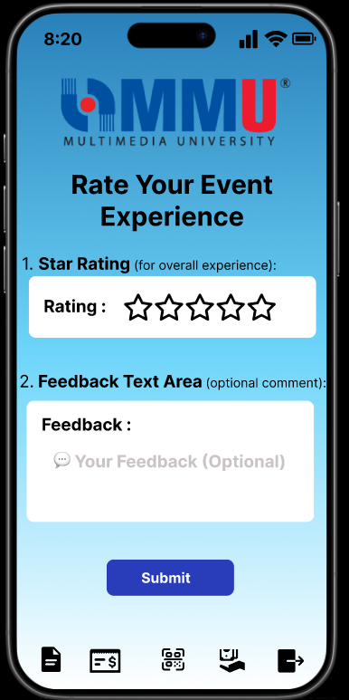

**Figure 2.2.12: Rating Page (User)**

This is the rating page for users of Campus Event Check-in System (CECS). In this page, it requires users to rate the stars regarding the experience and insert comment in the feedback area(optional). Click ‘Submit’ to enter the next page. Users can choose the icon below that represents the function of event lists, payment receipt, scan QR code, refund status and logout.

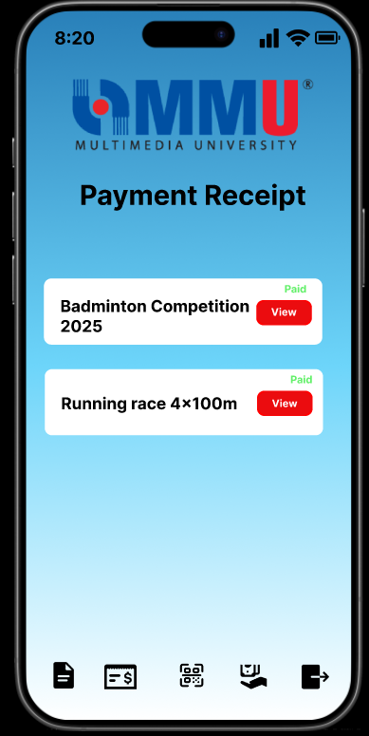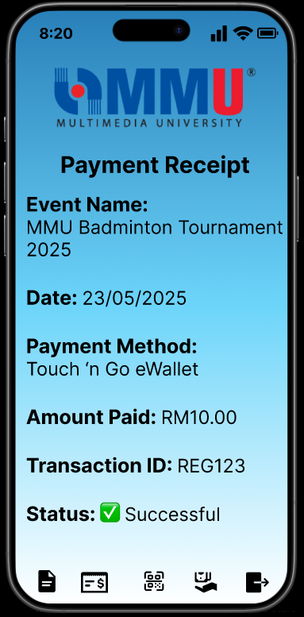

**Figure 2.2.13: Payment Receipt Page (User)**

This is the payment receipt page for users of Campus Event Check-in System (CECS). Users can click the icon below the page and it will move to the payment receipt page. Users can click the ‘View ’button and it will show the details of the receipt. Users can choose the icon below that represents the function of event lists, payment receipt, scan QR code, refund status and logout.

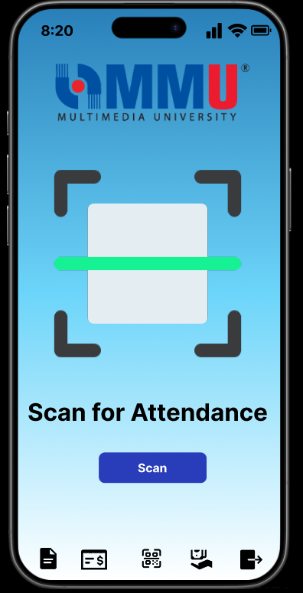

**Figure 2.2.14: Scan Attendance Page (User)**

This is the scan attendance page for users of Campus Event Check-in System (CECS). Users can click the icon in the middle to enter this page. Users can click the ‘Scan’ button to scan the QR Code. Users can choose the icon below that represents the function of event lists, payment receipt, scan QR code, refund status and logout.

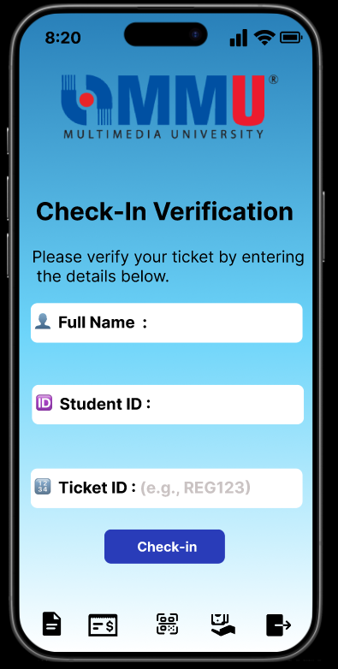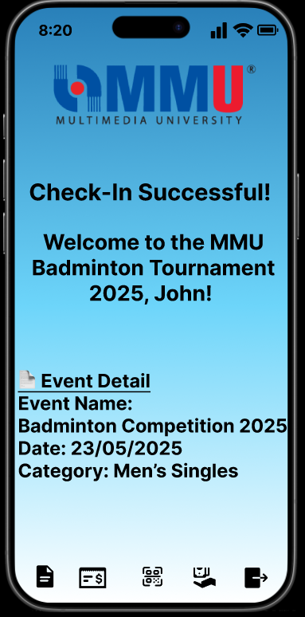

**Figure 2.2.15: Verification Page (User)**

This is the verification page for users of Campus Event Check-in System (CECS). After users scan the attendance, they can fill in the name, student id and ticket id to check in the event. Users can click the ‘Check-in’ button to finish it. After finishing the verification, it will move to the next page that shows the check-in successfuly. Users can choose the icon below that represents the function of event lists, payment receipt, scan QR code, refund status and logout.

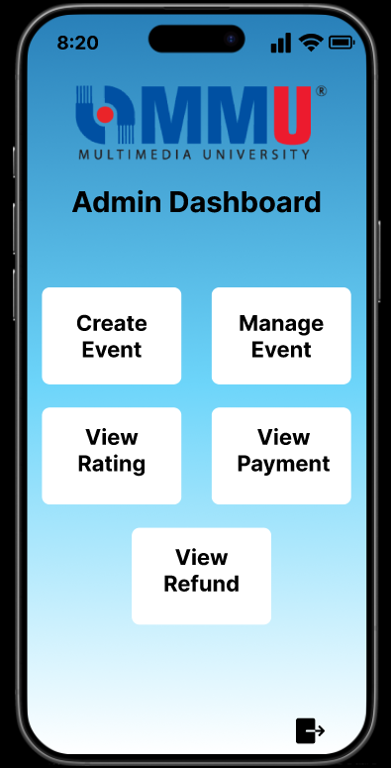

**Figure 2.2.16: Dashboard Page (Admin)**

This is the dashboard page for admin of Campus Event Check-in System (CECS). In this page, there are five functions to choose from which are ‘Create Event’, ‘Manage Event’, ‘View Rating’, ‘View Payment’, ‘View Refund’. Admins can choose the icon to logout the system.

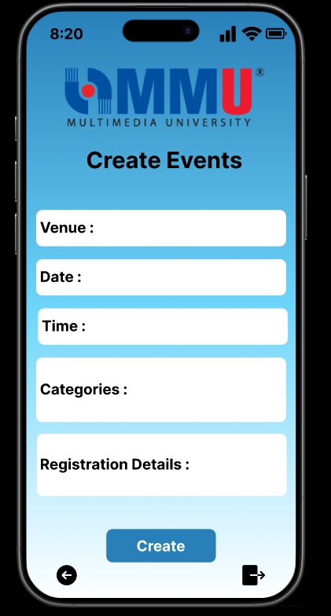

**Figure 2.2.17: Create Event Page (Admin)**

This is the create event page for admin of Campus Event Check-in System (CECS). In this page, there are venue input, date input, time input, categories input and registration details input that enable admins to enter to create the event. Admins can choose the icon below to back to the next page or logout the system.

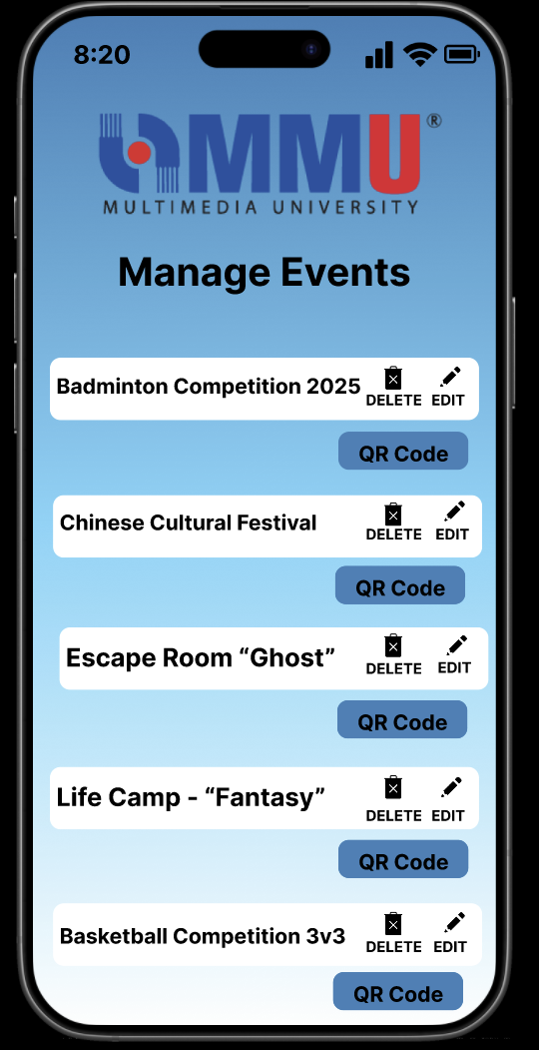

**Figure 2.2.18: Manage Page (Admin)**

This is the manage event page for the admin of Campus Event Check-in System (CECS). In this page, there are event lists to choose to edit, delete and generate the QR Code.

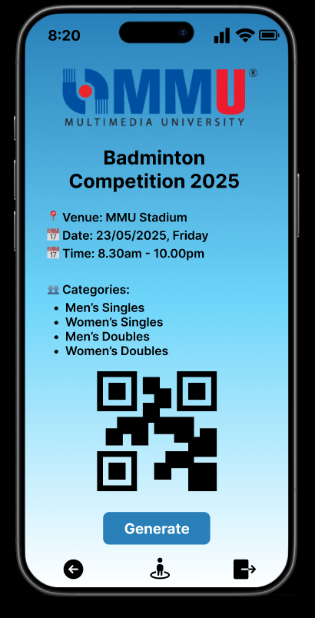

**Figure 2.2.19: Event QR Code Page (Admin)**

This is the event QR Code page for admin of Campus Event Check-in System (CECS). In this page, there are the details of the event selected and the OR Code of that event. Click the ‘Generate’ button to generate the QR Code. Admins can choose the icon below that represents ‘Back’, ‘Track attendance’ and ‘Logout’.

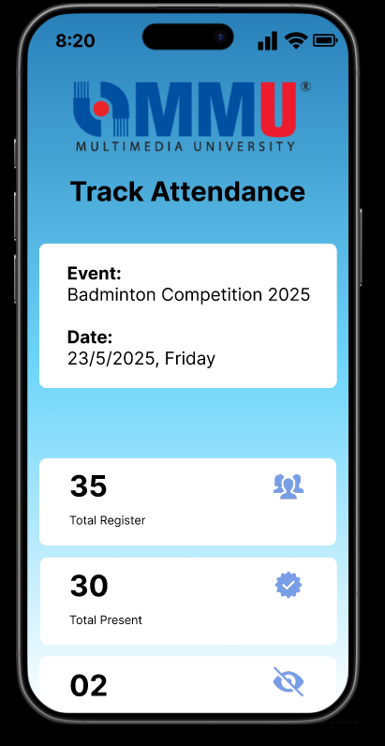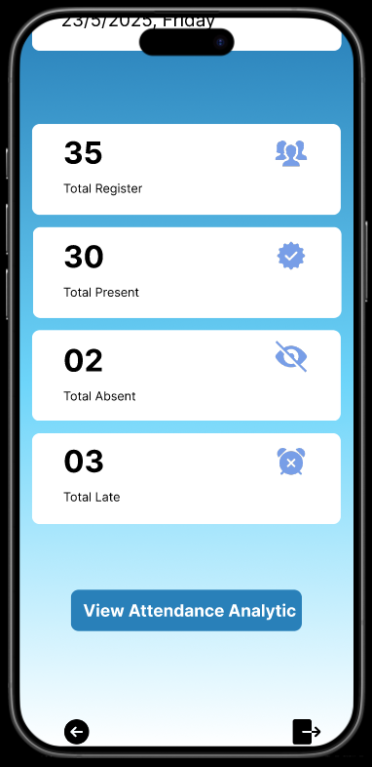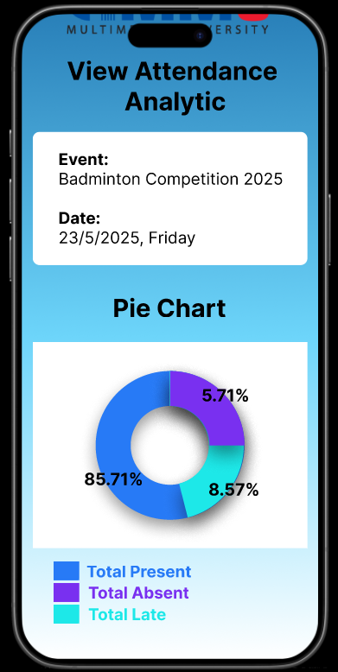

**Figure 2.2.20: Track Attendance Page (Admin)**

This is the track attendance page for admin of Campus Event Check-in System (CECS). In this page, there are the event title, event date, total register student, total present students, total absent students and total late students. Click the ‘View Attendance Analytic’ button to view the pie chart that shows the percentage of the students' attendance. Admins can choose the icon below that represents ‘Back’, ‘Track attendance’ and ‘Logout’.

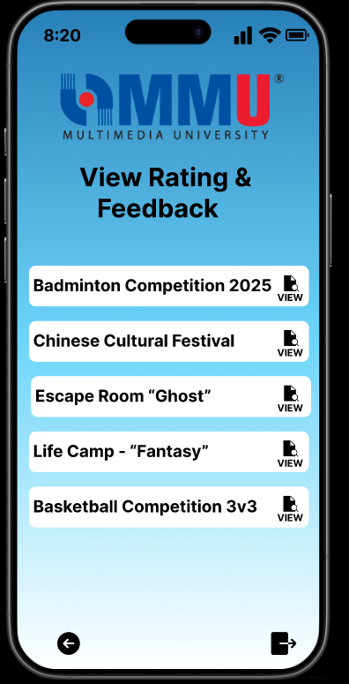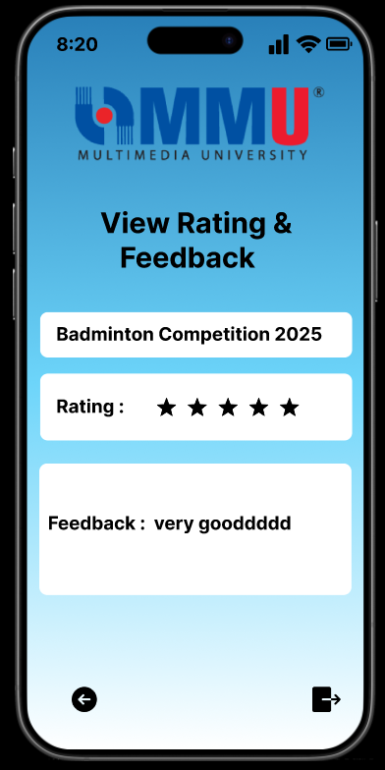

**Figure 2.2.21: Event Rating Page (Admin)**

This is the event rating page for admin of Campus Event Check-in System (CECS). In this page, admins choose the events to view and move to the next page. The next page will show the rating and the feedback of the selected event. Admins can choose the icon below that represents ‘Back’ and ‘Logout’.

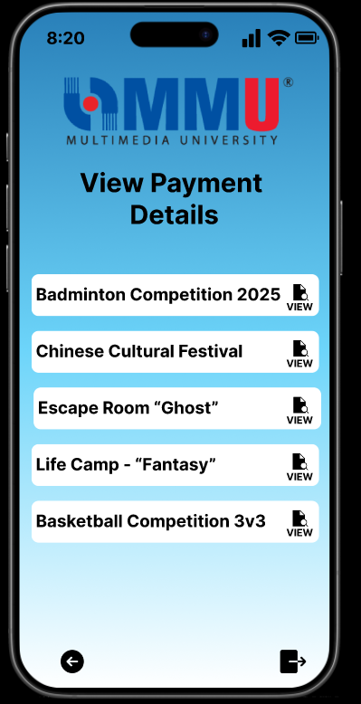

**Figure 2.2.22: View Event Payment Page (Admin)**

This is the view event payment page for the admin of Campus Event Check-in System (CECS). In this page, admins choose the events to view the payment details of each event. The next page will show the rating and the feedback of the selected event. Admins can choose the icon below that represents ‘Back’ and ‘Logout’.

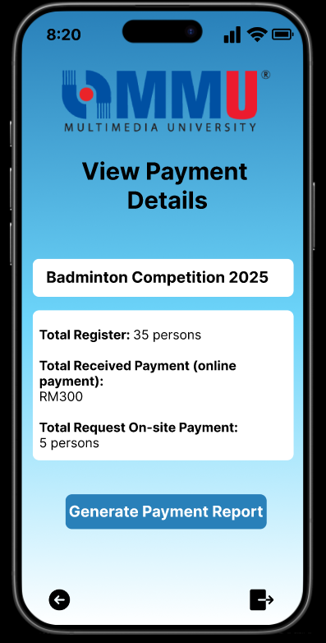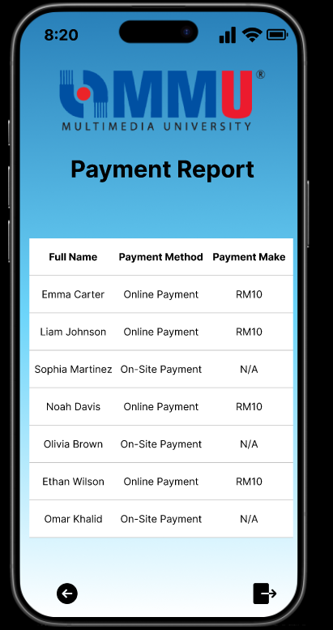

**Figure 2.2.23: View Payment Details Page (Admin)**

This is the view payment details page for admin of Campus Event Check-in System (CECS). In this page, there are the details (total register, total received payment and total request on-site payment) shown. Click the ‘Generate Payment Report’. The next page will show the full name, payment method and the payment made by the students. Admins can choose the icon below that represents ‘Back’ and ‘Logout’.

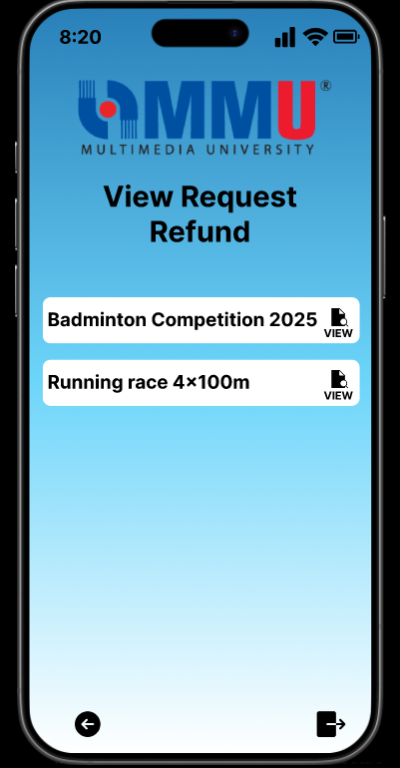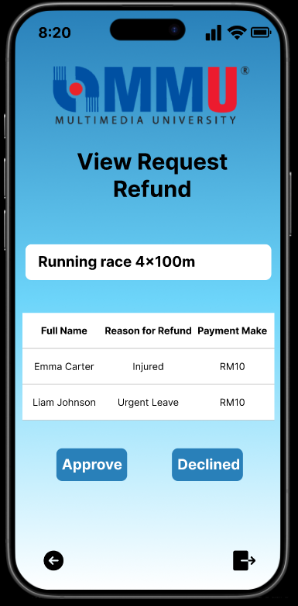

**Figure 2.2.24: View Event Request Refund Page (Admin)**

This is the view request refund page for the admin of Campus Event Check-in System (CECS). In this page, admins can choose the event to view the request refund. Admins can view the full name, reason for refund and payment made on the next page. Click the button ‘Approve’ or ‘Declined’ to decide the request. Admins can choose the icon below that represents ‘Back’ and ‘Logout’.

#### **2.2.1 Summary Feedback**

1. As stakeholders, we’re happy with the prototype of the Campus Event Check-in System. The flow—from browsing events to registration, payment, QR check-in, and post-event feedback—works smoothly. The flexibility of online and onsite payments is especially convenient, and it's helpful to see which events have already been joined.  
    The admin dashboard is also intuitive, allowing easy event management, feedback viewing, and refund processing.  
    To further delight users, we suggest adding calendar sync so students can add events directly to their personal schedules. For admins, a visual heatmap of check-ins could help identify peak times and popular events. A badge or point system could also encourage student participation.
2. As another stakeholder reviewing the system, I found the interface clear, well-structured, and user-friendly. Students can effortlessly complete all major tasks—event registration, payment, refunds, and QR check-in.  
    The admin features are also straightforward and effective. To enhance student engagement, we recommend enabling friend participation visibility, allowing users to see which friends are attending the same events. A shareable event link would also help promote events. Additionally, adding digital attendance rewards, like badges, could encourage consistent participation.

## **3 Requirements Categorization Summary**

**Figure 3.1 : Kano Model For Requirements Categorization Summary**

**Table 3.1 : Kano Model For Requirements Categorization Summary**

| **Identifier** | **Requirement** | **Kano Category** | **Elicitation Method** | **Description** |
| --- | --- | --- | --- | --- |
| REQ_001 | View Event List | Dissatisfier | Prototype + Questionnaire | Students can browse available events to join. |
| REQ_002 | Register for Event | Dissatisfier | Prototype + Questionnaire | Allows students to sign up for events via the system. |
| REQ_003 | Make Online Payment | Dissatisfier | Prototype + Questionnaire | Users can choose an online method (e.g., FPX, Touch ’n Go) to complete payment for events. |
| REQ_004 | Make Onsite Payment | Dissatisfier | Prototype + Questionnaire | Students can opt to pay physically at the event counter using QR code verification. |
| REQ_005 | Check-In via QR Code | Dissatisfier | Prototype + Questionnaire | Students scan a QR code during the event to mark their attendance. |
| REQ_006 | Create Event | Dissatisfier | Prototype + Questionnaire | Enables admin to input event information to publish new events on the platform. |
| REQ_007 | Manage Event | Dissatisfier | Prototype + Questionnaire | Lets admins edit, update, or remove event details from the system. |
| REQ_008 | Generate QR Code | Dissatisfier | Prototype + Questionnaire | Allows admins to create QR codes used for student event check-in. |
| REQ_009 | Generate Payment Report | Dissatisfier | Prototype + Questionnaire | Admins can generate a financial report for event payments received. |
| REQ_010 | Receive Notification | Satisfier | Prototype + Questionnaire | Students can receive notification when an event successfully register. |
| REQ_011 | Request Refund | Satisfier | Prototype + Questionnaire | Students can submit a refund request by providing a reason and payment receipt. |
| REQ_012 | View Payment Receipt | Satisfier | Prototype + Questionnaire | Students can view or download receipts for past event payments. |
| REQ_013 | Rate Event | Satisfier | Prototype + Questionnaire | Allows users to submit a rating after attending an event. |
| REQ_014 | View Rating or Feedback | Satisfier | Prototype + Questionnaire | Displays ratings and comments submitted by students for each event. |
| REQ_015 | Track Attendance | Satisfier | Prototype + Questionnaire | Allows real-time tracking of students who check in for events, helping admins monitor attendance. |
| REQ_016 | View Attendance Analytic | Satisfier | Prototype + Questionnaire | Admins can view attendance data visualizations to assess participation rates. |
| REQ_017 | Handle Refund Request | Satisfier | Prototype + Questionnaire | Enables users to request refunds and allows finance/admin to manage and respond to those requests. |
| REQ_018 | Event Attendance Rewards | Delighter | Questionnaire | Students can earn digital badges or points for attending multiple events. |
| REQ_019 | Friend Participation Visibility | Delighter | Questionnaire | Allows students to see which friends have joined an event. |
| REQ_020 | Event Calendar Sync | Delighter | Questionnaire | Syncs registered events with a student’s personal calendar (e.g., Google Calendar). |
| REQ_021 | Shared Event With Friends | Delighter | Questionnaire | Students can share events via link or social media with friends. |
| REQ_022 | Auto Close Registration | Delighter | Questionnaire | Automatically stops event registration when capacity is reached. |
| REQ_023 | Check-In Heatmap | Delighter | Questionnaire | Provides a visual heatmap of check-in data, showing where and when most attendees checked in. |

## 

## **4 System Functionalities**

The overall functions of the Campus Event Check-in System with Student ID and Payment Integration include:

### **4.1 Login**

**a. Student**

* Students can log in to the mobile system using their university credentials through the Authentication Server.

**b. Admin**

* Admins (acting as event organizers) also log in using university credentials to access event management features.

### **4.2 Event Management (Admin)**

**a. Event Creation and Editing**

* Admins can create, update, or delete events including event title, date, time, venue, category.

**b. QR Code Generation**

* A unique QR code is generated for each event, used for student check-in.

**c. Real-Time Attendance Tracking**

* Admins can monitor student check-ins live using the QR system and access analytics for event participation.

**d. Feedback and Report Generation**

* Admins can view submitted ratings/feedback and generate attendance or payment reports.

**e. Refund Approval**

* Admins can review and approve or decline refund requests submitted by students.

### 

### **4.3 Event Participation (Student)**

**a. View Event List**

* Students can browse available campus events.

**b. Event Registration**

* Students register for selected events by filling in their full name, age, phone number, email, category.

**c. Payment Processing**

* Students may pay using FPX, Touch ‘n Go, or select On-site payment. Payment receipt is generated upon success.

**d. QR Code Check-In**

* On event day, students scan the event QR code and enter their name, student ID, and ticket ID to check in.

**e. Feedback Submission**

* After attending, students can provide feedback and rate the event from the receipt or history page.

**f. View Payment History & Receipt**

* Students can view a full list of payments made receipts for each.

**g. Request Refund**

* Students can request refunds from the payment receipt page by submitting the reason.

### 

### **4.4 Notification and Communication**

**a. Real-Time Notifications**

* Students receive automatic push notifications after registration and payment.

### **4.5 Cross-Functional Features**

**a. Role-Based Dashboard**

* Students see their registered events, payment status, and upcoming events.
* Admins view overall participation, pending refunds, and attendance analytics.

**b. Role-Based Access Control**

* Ensures that students only access user functions and admins manage event-related modules.

## **5 Proof For Task 4**

<https://youtu.be/FZKKeB_HG3k>